Employment Profile.
Name of applicant: _______Alexander Antibody_____________________________________
Our name for the applicant (i.e. skin, histamine, etc): ______Antibody_______________
Job Title: _____Arresting Officer___________

Image of applicant

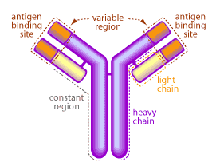

Job Description:

Mr Antibody is also known as a ‘receptor’. He helps a B cell recognize an intruder in the body. He is highly trained to recognize specific criminals (pathogens). Mr Antibody will stick to this intruder and will hold it ‘under arrest’. This happens so that the intruder cannot move or multiply to make more intruders (pathogens), and allows his colleagues (Killer T-Cells) to come and finish the job.

Employment Profile.
Name of applicant: ____________________________________________
Our name for the applicant (i.e. skin, histamine, etc): _____________________________________

Job Title: __________________________________________________

Image of applicant

Job Description:

